Let the Practice Know Your Views

Lawton House Surgery is always looking for ways to improve the services it offers to patients. To do this effectively we need to know what you think about the services you receive. Tell us what we do best and where we don’t meet your expectations. Also, give us any ideas and suggestions that you may have.

You can do this by:

Completing the Comments Form (we will be immediately aware of your comment)

or

Speaking to one of the management staff, if they are not available please address your comments to the receptionist. (we will be immediately aware of your comment)

or

Completing a Friends and Family form available in the waiting area of the practice

or

Making a comment of the “NHS Choices” Website
https://www.nhs.uk/Services/GP/LeaveReview/DefaultView.aspx?id=43888
We review the reviews on a regular basis but are unable to respond to concerns, which we would rather receive directly to the practice.

Comments Form

Name: ____________________________________

Address: __________________________________

__________________________________________

__________________________________________

Telephone: ________________________________

Date: _____________________________________

Details:

Signed: ___________________________________

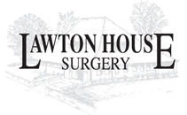
Bromley Road, Congleton, Cheshire, CW12 1QG

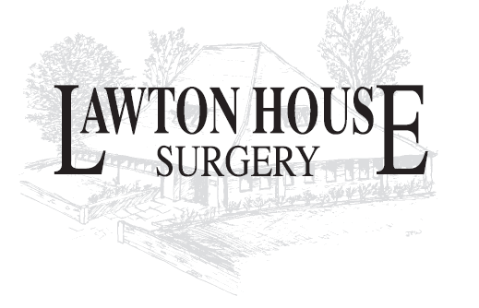
Telephone: 01260 275454
Website: www.lawtonhousesurgery.nhs.uk

Complaints, Compliments and Comments Leaflet

Partners:
Dr Katherine Savile
Dr Matthew Taylor
Dr Tom Rigby
Dr Paul Bishop
Dr Fathi Eid

Salaried GPs:
Dr Claire Gooding
Dr Colin Coulthard
Dr Vicky Lally

Management:
Mrs Melanie Lyman - Practice Manager
Mrs Roz Broad - Deputy Practice Manager
Mrs Heather Briggs – Reception Manager

(November 2021)

Complaints Procedure

We always try to provide the best service possible but there may be times when you feel that this has not happened.

The following information explains our complaints procedure. We will use it to look into and if necessary correct any problems that you may have identified or mistakes that may have been made.

If you use this procedure it will not affect your right to complain to NHS England should you wish to do so. Please note that we have to respect our duty of confidentiality to patients and therefore patients’ consent will be necessary if the patient themselves do not make a complaint.

How to complain
Most problems can be sorted out quickly and easily, often at the time they arise with the person concerned and this may be the approach you try first. Where you are not able to resolve your complaint in this way and wish to make a formal complaint, please contact our Practice Manager, Mrs Melanie Lyman. Full details will be taken and a decision made on how best to undertake the investigation.

We believe it is important to deal with complaints swiftly so you will usually be offered an initial response within 3 working days to acknowledge your complaint and a full explanation of reasons why and how the complaint may have come about within the following 28 days.

Complaining on behalf of someone else
We keep to the strict rules of medical and personal confidentiality. If you wish to make a complaint and are not the patient involved, we will require the written consent of the patient to confirm that they are unhappy with their treatment and that we can deal with someone else about it.

Where the patient is incapable of providing consent due to illness or accident it may still be

possible to deal with the complaint.

Please provide the precise details of the circumstances which prevent this in your covering letter.
Please note that we unable to discuss any issue relating to someone else without their express permission, which must be in writing, unless the circumstances above apply.

We may still need to correspond direct with the patient, or may be able to deal direct with the third party, and this depends on the wording of the authority provided

Patient Services
As a patient, relative, carer or any other member of the public, you may have questions about the services we provide and may need someone to turn to for on-the-spot help and advice. This is where Patient Services can help.

For all patient complaints and enquiries about any other local health service:
Under the NHS Complaints Procedure, you can choose to complain to either the local health service directly or to the commissioner of that service, which for most local services will be NHS Cheshire CCG.

If you choose to complain to the commissioner, the NHS Eastern Cheshire CCG Complaints, Concerns and Compliments Team can be contacted on the following details:
Patient Advice and Liaison (PALs):
Mail to: cheshireccg.patientexperience@nhs.net
Tel: 0800 132 996
Complaints: cheshireccg.patientexperience@nhs.net
0800 132 996
Or via the following postal address:
Complaints, Concerns and Compliments

1st Floor West Wing
New Alderley Building
Macclesfield District General Hospital
Victoria Road
Macclesfield
SK10 3BL

For all complaints and enquiries about local GPs, Dentists, Pharmacists and Opticians please contact:

Under the NHS Complaints Procedure, you can choose to either complain directly to the GP Practice, Dentist, Pharmacy, Opticians or to the commissioner of these services, which is NHS England.

If you choose to complain to NHS England, you can contact them using the following details:
Phone: 0300 311 2233
Email: england.contactus@nhs.net
Write to: NHS England
PO Box 16738
Redditch
B97 9PT

Health Service Ombudsman
If you remain dissatisfied you can refer your complaint to the Health Service Ombudsman. This is an independent body set up to promote improvements in healthcare. If you wish to refer your complaint to the Health Service Ombudsman you must do so within 12 months of the event. You can do this in the following way:

Write to:
The Health Ombudsman
Millbank Tower
London
SW1P 4QP
Telephone: 0345 0154033
Website: www.ombudsman.org.uk

